Planning brief by | Audrey Fernandes Satar and Arif Satar
Date | AUGUST 2015
Teaching Artists are referred to the Briefing for the information to be included in these briefs.
Context
Arts subject | - Visual Arts
Context | B Ed Primary August to October 2015 Arts Challenge 2 for Visual Arts  This is planning for an introductory activity for Visual Arts that can be completed by a student on her/his own in about an hour.
Title of activity/brief | - The Secret (Life) of Picture Books
Overview | - Based on the 'secret' text provided write a short story (no more than 250 words)
The big picture/ Enduring questions/understandings | - Our personal journeys inform our creativity and learning process in the visual arts
Resources  Resources include any PowerPoint presentations/videos /etc. | - Paper, HB pencil, scissors, pencils
The TA Activity outlined:
Remember that it is possible to set out this same information in other formats. See the example provided for more detail. If another format is used please attach as an appendix to this document.
Remember there are some givens: e.g. warm up/cool down; space for reflection
Activity | Learning | Links | Extensions
The activity step by step | Explicit statement of the intended learning in terms of the Australian Curriculum: The Arts
- Warm Up  - Take an A4 sheet of paper and cut a 21 by 21 cm square  - Fold your square in half, marking the crease and open the sheet  - Fold the paper edges to the centre and crease. Open up again  - Fold the other edges to the centre and crease.  - Fold each corner from the nearest crease towards the edge of the paper, leaving around 1 cm from the edge to form a flap  You should end up with an uneven octagon  - Fold back the edges over the triangular corners to make a flap  - Pull the flaps outwards to make a box. You may have to re-crease some of the folds to shape your box  - You are required to bring your box to the workshop  - You may find another way of constructing the box. BE CREATIVE ! | WARM UP  Observing and constructing:  To take a piece of paper and transform it into a three dimensional object  Practical:  The use of visual arts materials  Materials & Processes:  Investigating possibilities of materials  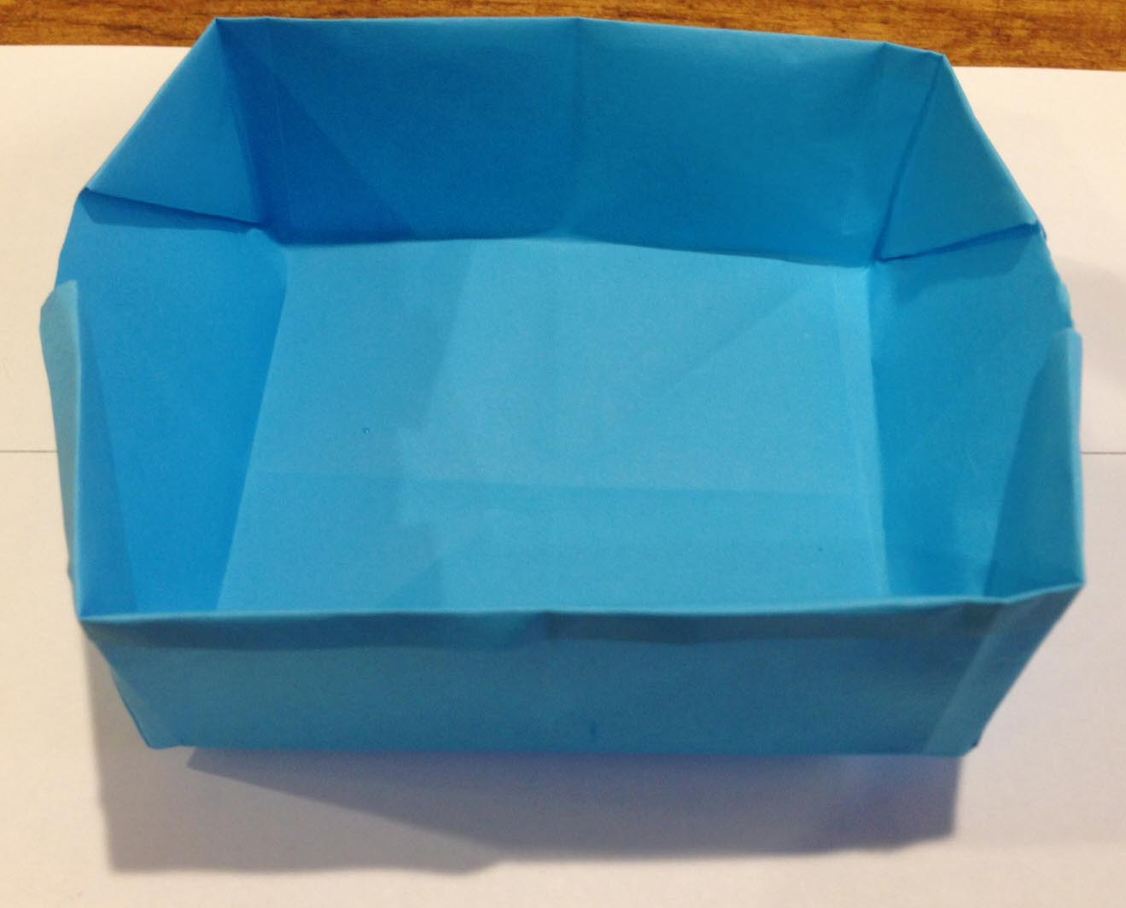  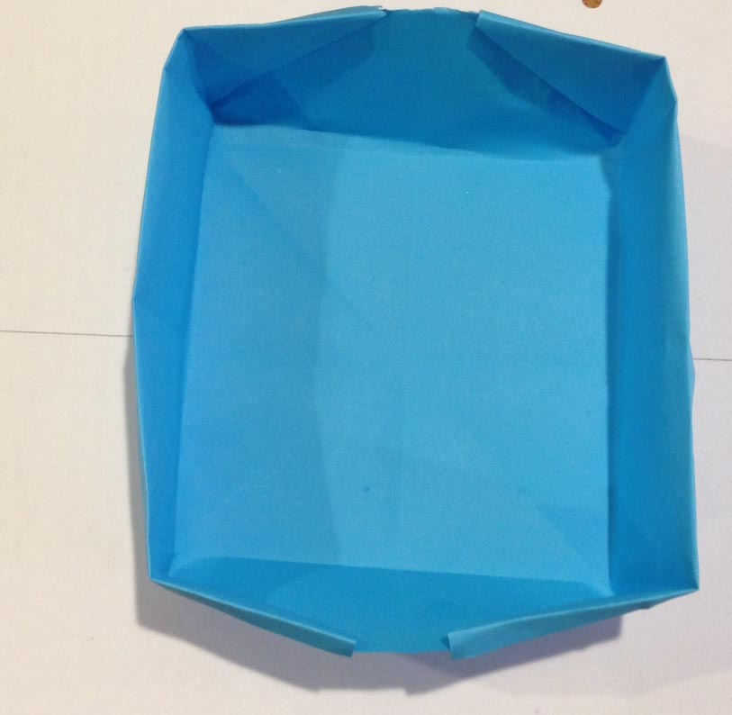  Experimenting and manipulating with everyday materials
- Create a short story (no more than 250 words) using the text provided (framing text) | Representation and Viewpoints:  To build a context through imagined and real events or histories  Cultures and Histories:  To build a narrative based on personal or imagined experiences  Processes:  Investigating and experimenting how stories can inform visual representations  Conceptual:  To develop an idea into a visual representation  To predict the meaning of text and translate into visual imagery | Page 1  We worked in a big garden near the creek.  Page 2  There were two water tanks and a  windmill next to the garden.  Page 3  We had to work very hard in the hot sun.  Page 4  One day, in the wet season, the people  working in the garden saw a storm,  with a big wind, coming in from the south.  Page 5  There was something  inside that storm!  The old men saw it coming across the creek.
The MU pedagogy focus activity will be outlined in response to the information from the TAs.

